Lab 6: Advanced Power BI Visual Analytics
RollNo: BSDSF24M029
Name: Abdullah Ayub

Dashboard Pages and Key Findings

Page 1: Sales Comparison Dashboard
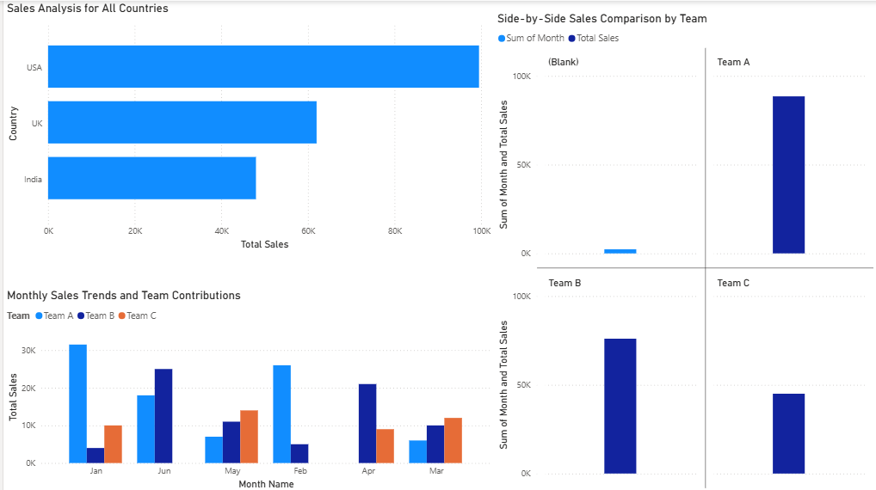
Geographic Leaders: The clustered bar chart identifies which countries are driving the bulk of TechMart's revenue, allowing for targeted regional investments and resource allocation.
Team Contribution: By using small multiples and legends, we can observe how Teams A, B, and C contribute to monthly totals independently and collectively, providing a clear view of team-specific performance.
Drill-down Capability: The Country → Team hierarchy enables managers to start at a high-level global view and "drill into" a specific nation to investigate local team performance and accountability.

Page 2: Trend and Composition Analysis
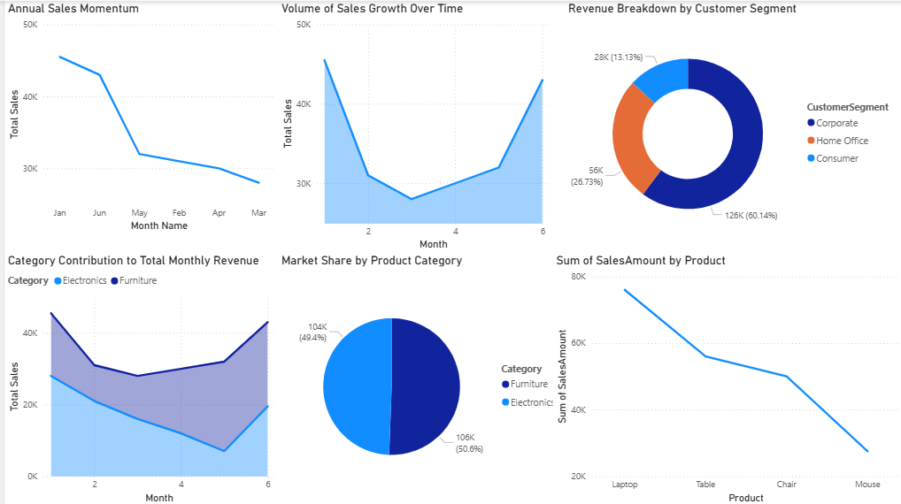
Seasonality: Line and Area charts track sales momentum across the year, highlighting peak months that are critical for inventory management and supply chain planning.
Category Mix: The Stacked Area chart visualizes the shifting contribution of Electronics vs. Furniture categories over time, identifying which products sustain growth during different quarters.
Incorrect Visual Analysis: Per lab requirements, a Line Chart was created using Product as the Axis. This is technically incorrect because line charts imply a continuous trend or chronological progression. Connecting discrete categorical items (like different products) with a line creates a misleading "slope" that suggests a relationship or trend where none exists. Bar charts are the correct alternative for comparing these discrete categories.

Page 3: KPI Dashboard
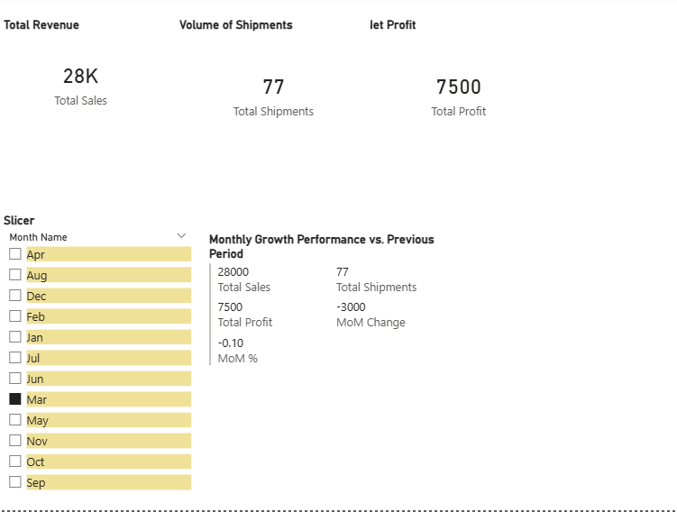
Instant Visibility: Core metrics including Total Sales, Total Profit, and Total Shipments are displayed via card visuals for immediate executive review of organizational health.
Growth Indicators: The Month-over-Month (MoM) calculations and percentage change indicators provide vital context, showing whether the business is currently expanding or contracting compared to the previous period.

Page 4: Detailed Analysis
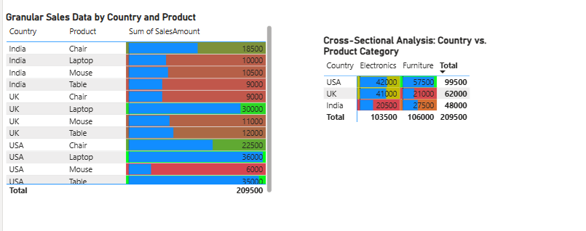
Cross-Sectional View: The Matrix visual correlates Country performance against Product Categories, revealing specific regional product preferences and market gaps.
Visual Cues: Conditional formatting (color scales) and data bars highlight high-volume regions and products instantly, reducing the cognitive load required to identify top performers within dense data tables.

Page 5: Advanced Analysis
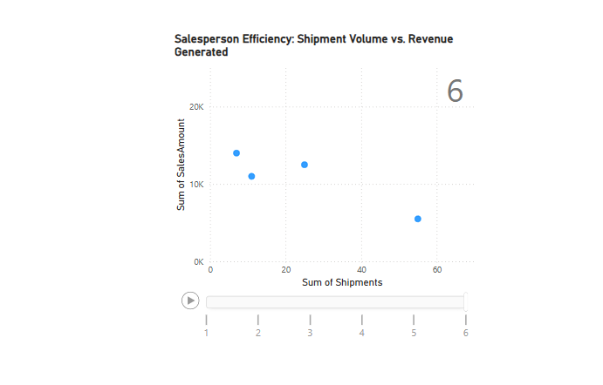
Outlier Detection: The Scatter plot maps Shipments against Sales to find high-volume but low-profit outliers among the sales staff, identifying potential training needs or pricing issues.
Dynamic Motion: The Play Axis animates monthly performance, showing how individual salespeople move toward or away from revenue targets over the course of the year.

Page 6: Contribution Analysis
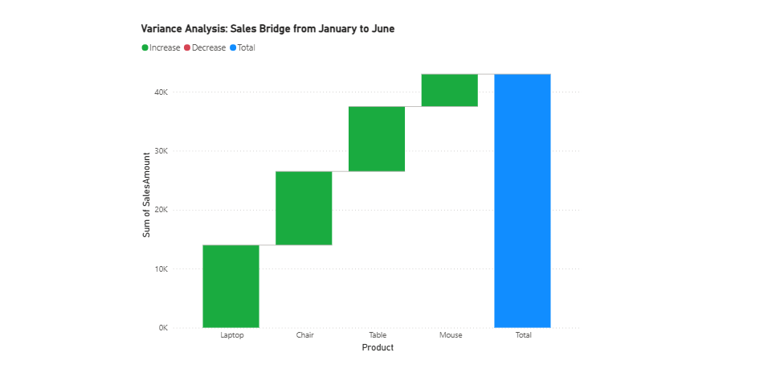
The Bridge: The Waterfall chart explains the change in revenue between January and June, acting as a "bridge" to explain variance and mid-year performance shifts.
Growth Drivers: It isolates exactly which products drove the increase or decrease in total mid-year sales, providing actionable insights for strategic planning in the following half-year.

3. Storytelling Enhancements Applied

Custom Tooltip Page
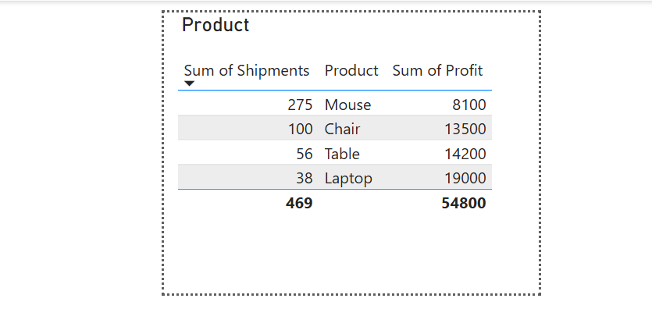
Functionality: A hidden report page was created and configured as a Tooltip. This page contains a detailed breakdown of Sales by Product and Profitability. When a user hovers over any data point on the main "Sales by Country" bar chart, this tooltip dynamically filters to show exactly which products are driving that selected country's performance without leaving the main dashboard.

Additional Enhancements
Meaningful Titles: All visuals were renamed from default technical names to insight-driven titles (e.g., "Regional Performance Analysis" instead of "Sum of Sales by Country").
Conditional Formatting: Applied data bars to the Matrix visual to emphasize volume and variance across categories.
Dynamic Title (DAX): Implemented a DAX-driven title for the Waterfall chart that updates automatically based on the user's slicer selections (e.g., "Sales Variance for [Selected Category]").

4. Analytical Questions
1. Why should line charts use time-based axes? Line charts represent continuous trends. Time is a continuous dimension that gives meaning to the "slope" of the line. Using discrete categories (like Products) on a line chart implies a connection between items that do not have a chronological relationship, leading to false visual interpretations.
2. Why are pie charts ineffective with many categories? As the number of slices increases, the area of each slice becomes smaller and harder to distinguish. The human eye is poor at comparing angles and area sizes of many thin slices compared to comparing the length of bars in a bar chart.
3. Why are KPI cards incomplete without context? A single number like "$50,000" doesn't indicate performance quality. Without a benchmark (such as the previous month, a target, or a year-over-year comparison), a user cannot tell if the result is positive, negative, or stagnant.
4. How do scatter plots help identify outliers? By plotting two variables (X and Y), scatter plots allow users to see patterns and correlations. Data points that fall far away from the main cluster or the trend line are outliers, representing unusual behavior such as extreme efficiency or unexpected losses.
5. Why is drill-down important in dashboards? Drill-down allows for a "top-down" exploration of data. It keeps the report clean by showing high-level summaries first while giving the user the power to investigate the specific details (root causes) within the same visual, improving the user experience.

